**Installation Instructions on Android Studio and Android SDK on Windows 10**

The Android build system compiles app resources and source code, and packages them into APKs or Android App Bundles that you can test, deploy, sign, and distribute. Android Studio uses [Gradle](https://gradle.org/), an advanced build toolkit, to automate and manage the build process, while allowing you to define flexible custom build configurations. Each build configuration can define its own set of code and resources, while reusing the parts common to all versions of your app. The Android plugin for Gradle works with the build toolkit to provide processes and configurable settings that are specific to building and testing Android applications.

Gradle and the Android plugin run independent of Android Studio. This means that you can build your Android apps from within Android Studio, the command line on your machine, or on machines where Android Studio is not installed (such as continuous integration servers). If you are not using Android Studio, you can learn how to [build and run your app from the command line](https://developer.android.com/studio/build/building-cmdline). The output of the build is the same whether you are building a project from the command line, on a remote machine, or using Android Studio.

1. **System Requirements**
   1. Operating System Version - Microsoft Windows 7/8/10 (32-bit or 64-bit).
   2. Random Access Memory (RAM) - Minimum 4 GB RAM and 8 GB RAM recommended.
   3. Free Disk Space - Minimum 2 GB and 4 GB recommended.
   4. Minimum Required JDK Version - Java Development Kit (JDK) 8.
   5. Minimum Screen Resolution - 1280 * 800.resolution
2. **Download and Install Android Studio**

**Step 1:** To download the Android Studio, visit the **official**[**Android Studio** website](https://developer.android.com/studio) in your web browser.

**Step 2:** Click on the "Download Android Studio" option.

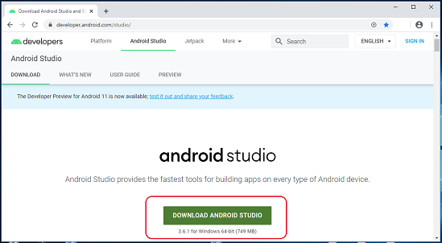

**Step 3:** Double click on the downloaded "Android Studio-ide.exe" file.

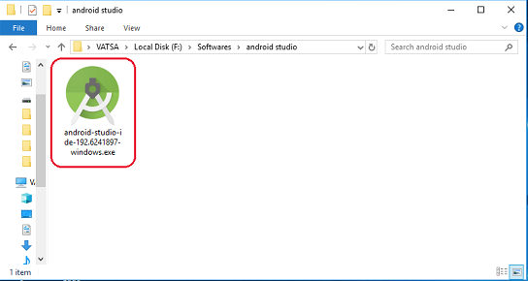

**Step 4:** "Android Studio Setup" will appear on the screen and click "Next" to proceed.

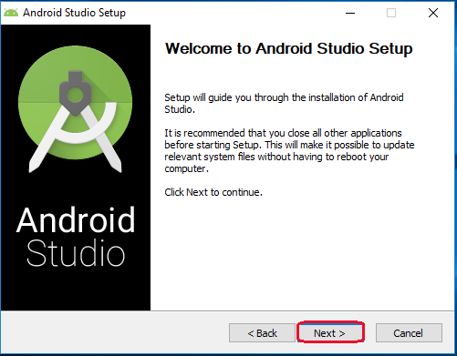

**Step 5:** Select the components that you want to install and click on the "Next" button.

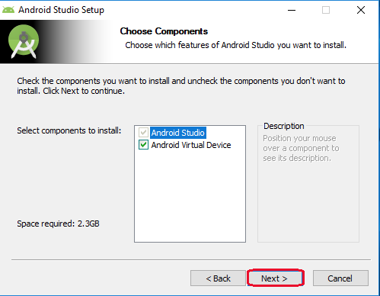

**Step 6:** Now, browse the location where you want to install the Android Studio and click "Next" to proceed.

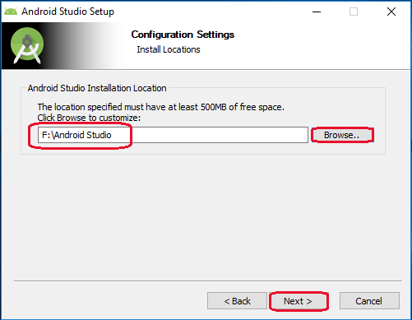

**Step 7:** Choose a start menu folder for the "Android Studio" shortcut and click the "Install" button to proceed.

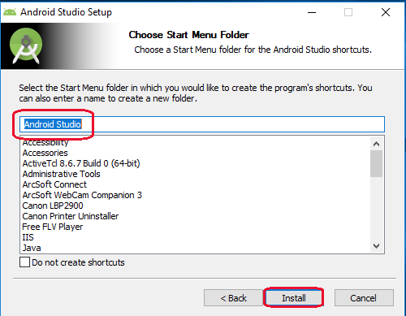

**Step 8:** After the successful completion of the installation, click on the "Next" button.

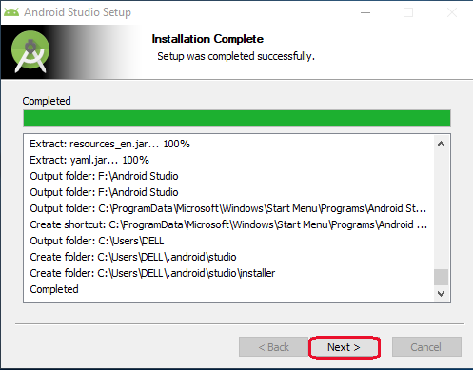

**Step 9:** Choose a start menu folder for the "Android Studio" shortcut and click the "Install" button to proceed.

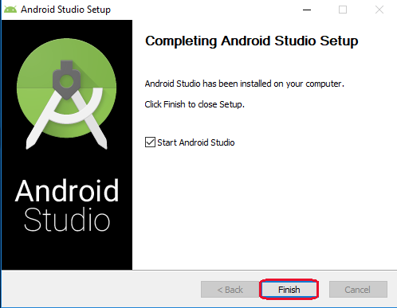

Now, your Android studio welcome screen will appear on the screen.

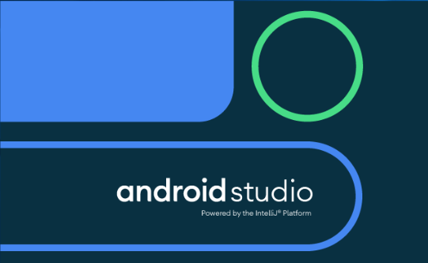

## **Step 10:** Android Studio Setup Configuration.

## "Android Studio Setup Wizard" will appear on the screen with the welcome wizard. Click on the "Next" button.

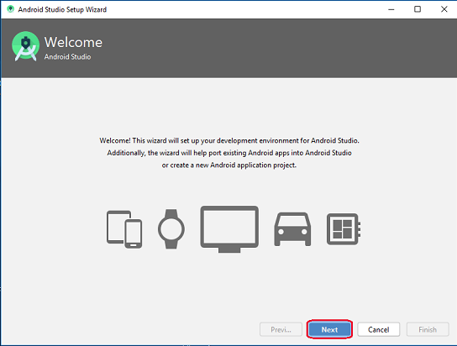

## **Step 11:** Select (check) the "Standard" option if you are a beginner and do not have any idea about Android Studio. It will install the most common settings and options for you. Click "Next" to proceed.

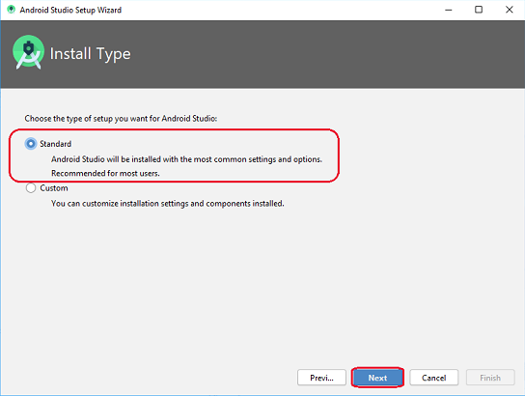

## **Step 12:** Now, select the user interface theme as you want. (I prefer Dark theme (Dracula) that is most liked by the coders). Then, click on the "Next" button.

## **Step 13:** Now, click on the "Finish" button to download all the SDK components and, the downloading and installation process of components gets started.

## 

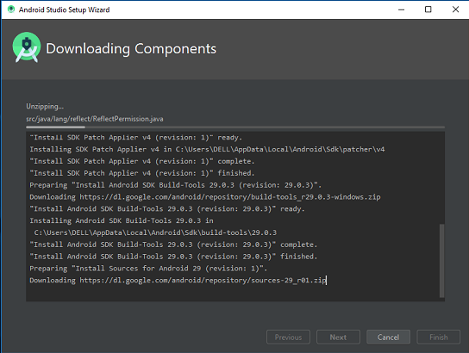

**Step 14 :** After downloading all the necessary components, click on the "Finish" button.

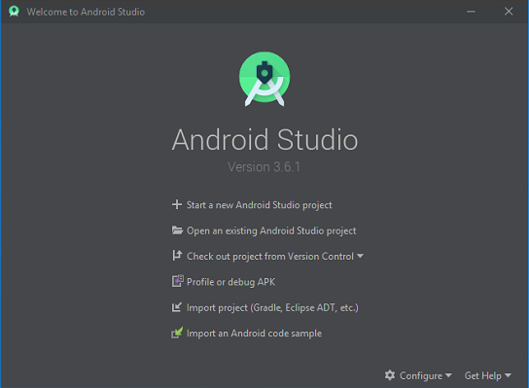

1. **Install Android SDK**

Follow these steps to download and install the latest version of Android SDK platform packages and tools on your host computer:

* 1. After installing Android Studio, follow any one of these steps to open SDK Manager from the Android Studio application:
  2. On the Android Studio landing page, select **Configure** > **SDK Manager**.

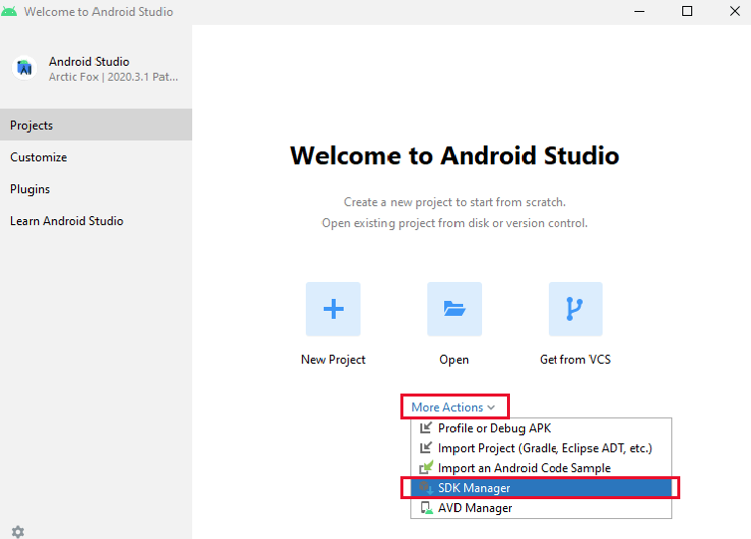

* 1. From your Android Studio application toolbar, select **Tools** > **Android** > **SDK Manager**.

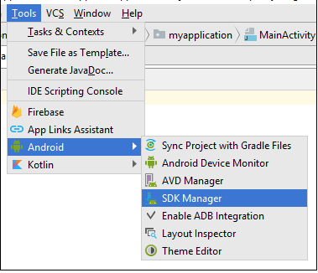

* 1. From your Android Studio application toolbar, click **SDK Manager**.



* 1. In the **Default Settings** dialog box, click these tabs to install Android SDK platform packages and developer tools
* **SDK Platforms** — Select the latest Android SDK package to compile your application with the latest version of SDK platform.
* **SDK Tools** — Select the latest Android SDK Build-Tools, NDK (Side by Side), and Android SDK Platform-Tools

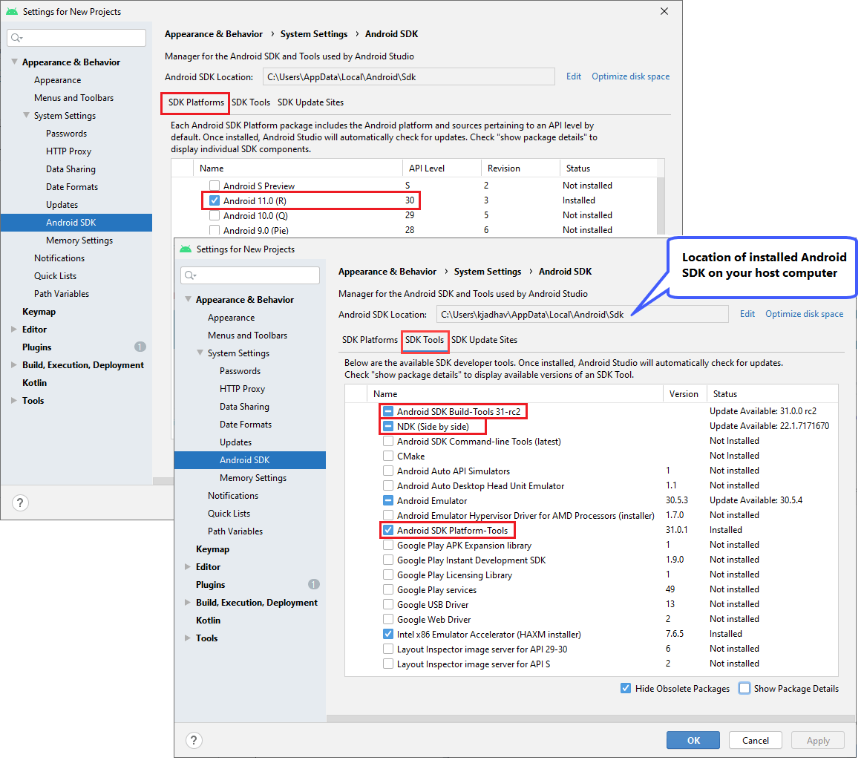

* 1. Click **Apply**. Android Studio starts installing the selected packages and tools on your computer. Once installed, the **Status** of the installed packages and tools changes from **Not installed** to **Installed**.
  2. Click **OK**.